**Leader Overview**

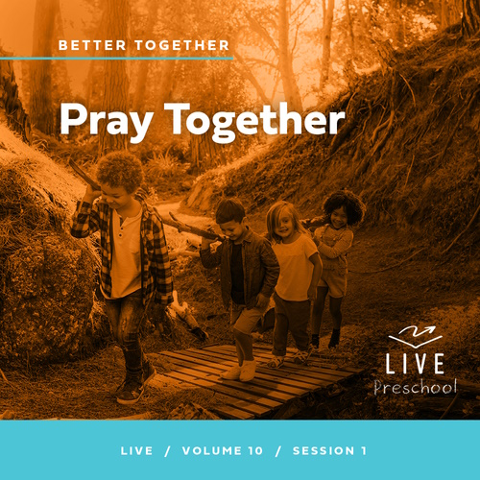

**Volume Overview**

**Better Together**

*The Christian life is never lived alone. When we become a Christian, we’re adopted into God’s family. We’re welcomed into a community. We’re meant to live and grow in faith together. But that takes humility and intentionality. We grow together as we pray and study Scripture together. We bear responsibility for one another by our encouragement and our honoring of those in authority. God is growing us together into one body, one family.*

**Session Overview**

**Pray Together**

*In this* **Live** *session, preschoolers will discover that we can pray together. They will also learn that God hears our prayers and responds to them. Kids will explore the story of Peter’s miraculous release from prison and the friends who gathered to pray for him. Preschoolers will learn that their prayers are powerful because God can do miracles.*

**Bible Lesson**

The Church Prays and Peter Is Set Free

[Acts 12:1–16](https://ref.ly/logosref/Bible.Ac12.1-16)

**Faith Fact**

Our prayers are powerful.

**Faith Verse**

[Ephesians 4:3](https://ref.ly/logosref/Bible.Eph4.3) (NLT)

Make every effort to keep yourselves united in the Spirit, biding yourselves together with peace.

**Preparing for the Session**

**Leader Preparation Time: 20–25 Minutes**

|  |
| --- |
| ***You Will Need***  *Preservice Activities*  *• Toys*  *• Game cards, five (Uno®, Skip-Bo®, etc.) or index cards*  *• Chocolate sandwich cookies*  ***Large Group***  *• Bible*  *• Worship songs (Song suggestions: “Alive with You” Lyric Video by Gateway Kids Worship; “I Need You” Lyric Video by Gateway Kids Worship; “Good to Me” Lyric Video by Elevation Church Kids*  *• For groups not using a phone or tablet only, add:*  *• Projector or TV*  *• Laptop*  *•* ***Faith Fact Sound*** *video (bell ringing)*  *•* ***Faith Fact Slide***  *•* ***Faith Verse Slide***  *•* ***Faith Verse Video***  *•* ***Bible Lesson Video A***  *•* ***Bible Lesson Video B***  ***Small Group***  *• Rope or jump rope long enough for each kid to place one hand on it while sitting in a circle.*  *•* ***Small Group Activity Page 1****, one per kid*  *•* ***Small Group Activity Page 2****, one per five kids*  *• Tape*  *• Scissors, one per kid*  *• Glue sticks, one per kid*  *• Floor-safe tape*  *• Rectangular metal cake pans, one per group*  *• Marbles or table tennis balls, one per group*  *• Large foam plates, one per kid and leader*  *• Water*  *• Disposable tablecloth*  *• Black pepper in shaker*  *• Liquid dish soap in a bowl*  To access session content and videos from a computer, visit: [***BibleEngagementProject.com/downloads***](https://bibleengagementproject.com/downloads) |
| ***Getting Ready***  ***Preservice Activities***  *• Set out toys and snacks.*  *• Practice leaning cards against each other to make them stand up.*  ***Large Group***  *• Download videos and slides if needed.*  *• Select worship song(s) and have them ready to play.*  ***Small Group***  *• Print copies of the* ***Small Group Activity Page 1****, one per kid.*  *• Print copies of the* ***Small Group Activity Page 2****, one per five kids.*  *• Optional: Cut apart the four strips so each kid can have a set.*  *• Optional: Glue the four strips into a chain for each kid.*  *• Tape a maze path on the floor for kids to follow.*  *• Arrange plates in the center of the disposable tablecloth on a table or the floor.*  *• Add enough water to cover the bottom of each plate.*  ***First time leading* Live *for Preschool? Check out the*** [**Facilitator Guide**](https://0b769b0ed3569ef9d18b-f88d8272f61086866d50d048b43ef630.ssl.cf2.rackcdn.com/sites/biblengagementproject/Listen_Facilitator_Guide.pdf)**.** |

**Preservice Activities**

*See what’s needed at the beginning of the session.*

**Bible Story Warm-Up**

• *As the kids enter, have them sit in a circle. Give a game card to five kids.*

When you came in today, I gave five of you a card. If you have a card, hold it up in the air. *(Group response)* I want you each to try to make your card stand up on its own.

• *Allow kids to try to stand up their cards on their own.*

Wow, that seemed impossible! Why don’t you each give your card to someone else and let them try?

• *Make sure each kid has a chance to try and stand up a card.*

I have an idea. Let’s try to put two of our cards together and see if we can get them to stand up that way.

• *Lean cards together to make an inverted V-shape that stands up.*

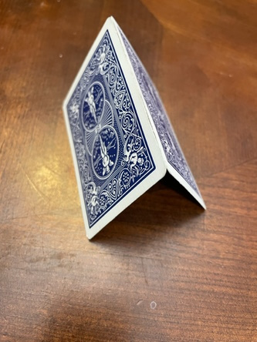

Wow! When we tried this by ourself, we couldn’t get our cards to stand up on their own. When we put our cards together, we were able to get them to stand. Let’s see if we can add more to this.

• *Allow kids to add their cards to create walls and a roof.*

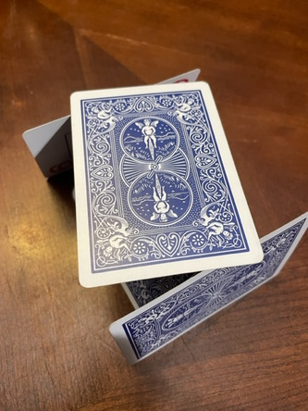

What was the best part of what we just did?

Was easier or harder for you when we put our cards together?

What is something else you’ve done when someone helped you?

The Bible is full of stories that help us know how to live our life. In our Bible story today, we’ll look at a time when God’s people joined together to see something amazing happen. I can’t wait to learn more about this with you today.

**Snack**

**Chocolate Sandwich Cookies**

Time for our snack. Does anyone like peanut butter and jelly? *(Group response)* What about cake and ice cream? *(Group response)* Can you think of other foods that go together? *(Allow responses.)* Those all sound so yummy!

• *Hand out cookies.*

Here’s another combination of things that go together—cookies and cream filling. As you eat your snack today, I want you to tell your neighbor one of your favorite snacks. If you and your neighbor have the same favorite snack, give each other a high five and then eat your snack. If you don’t have the same one, then say, “Enjoy,” to each other and eat your snack.

• *Allow time for kids to discuss favorite snacks and eat their cookies.*

Today, we’ll find out about something that is not only great to do together but also powerful.

**Free Play**

*Any extra time can be spent playing with toys.*

**Transition**

*A few minutes before service begins have kids make their way to the large group area and sit in their designated areas.*

**Large Group**

**25 Minutes**

*See what’s needed at the beginning of the session.*

**Introduction**

Hi, kids! I’m so excited to see you here today! My name is _______. We’ll have so much fun learning from God’s Word, the Bible, together. *(Hold up the Bible.)* If you’re excited to be here, wave your hand at me! *(Group response)*

Today, we’ll learn about Peter and some of his friends from the Bible. In our story, Peter was put in jail even though he hadn’t done anything wrong. Peter’s friends must have been scared for Peter, but they knew what to do. They got together at someone’s house and prayed for Peter. Who do you think heard their prayers? *(Group response)* Yes, God heard their prayers and did a miracle for Peter.

**Faith Fact**

God is so strong and powerful. He can do things that we can’t do. Those things are called miracles. He invites us to be a part of His miracles when we pray. That’s what our Faith Fact says. **Our prayers are powerful**. When we pray to our powerful God, He answers!

• *Show the* ***Faith Fact Slide.***

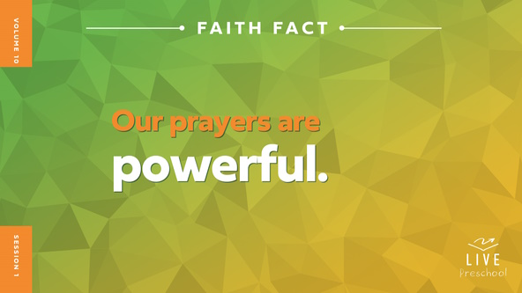

Let’s say our Faith Fact together. **Our prayers are powerful**. Let’s show our powerful muscles while we say it this time. *(Demonstrate making strong muscles.)* **Our prayers are powerful.** Awesome! Let’s shout it this time. **Our prayers are powerful**. Great job!

**Bible Time**

I love learning from God’s Word with you. We’ve got a special friend to help us do that. Let’s check in with Lizzy and explore a Bible story with her.

• *Play* ***Bible Lesson Video A****.*

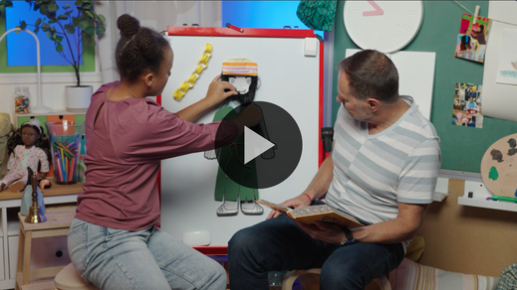

I’m so glad Grandpa and Lizzy gave us a little time to think! Let’s worship for a few minutes. Then, I’ll ask what you think will happen next in our Bible story.

**Worship**

God is so good. He loves you, me, and every person more than we can even understand. God is strong and powerful, too. Let’s tell God now how much we love Him.

**Praise**

Who wants to thank God for His great love? Wave your hands up high. *(Group response)*

Are you glad God hears us when we pray? Clap your hands and hold them like you’re praying. *(Group response)* Who wants to thank God for doing miracles? Show God two thumbs up. *(Group response)*

**Sing**

It’s awesome to remember how incredible God is. Now, let’s sing to our strong, powerful God.

• *Lead the kids in singing one or two songs. See song suggestions at the beginning of the session.*

**Prayer**

I hope you remember to pray to God every day. God hears every prayer we pray. He listens to the feelings of your heart and the things you think. As we pray, you can just talk to God. Let’s do that now. Can you bow your heads with me as we pray?

|  |
| --- |
| *Dear God, we praise You for who You are. You are strong and powerful, but You also care about the smallest things we care about. Thank You for loving us so well. Amen.* |

**Bible Time cont’d**

I think Grandpa and Lizzy are coming back soon! Let’s think about the answer to what happens next. Let’s each put on our thinking cap *(demonstrate).* What do you think? Were Peter’s friends sleeping because there was no hope for Peter? *(Point to the “pillow” graphic.)* Or were they praying for God to do a miracle for Peter? *(Point to the “prayer” graphic.)*

If you think Peter’s friends were sleeping, close your eyes and pretend to sleep. If you think Peter’s friends were praying, fold your hands like you’re praying. Ready? Choose your answer.

• *Pause while kids respond with the action.*

Let’s find out if you’re right! Here are Lizzy and Grandpa.

• *Play* ***Bible Lesson Video B****.*

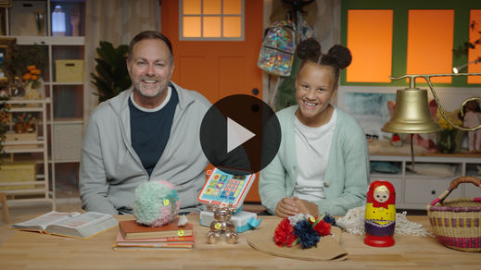

**Response Time**

*Play a worship song quietly.*

Let’s respond to what we’ve learned today. Think of someone in your life who needs prayer for something. Maybe it’s a friend, a brother or sister, or your mom or dad. Let’s believe together that God hears our prayers. He is powerful to do miracles. Let’s pray right now.

• *Have the kids repeat phrases of the prayer after you.*

|  |
| --- |
| *Dear God, thank You that You hear my prayers. I want to pray for someone I love. You know what they need. Please help them. Please show them Your love. I believe You can do miracles. I love You. Amen.* |

**Faith Verse**

Learning Bible verses is a great way to remember God’s power. Our Faith Verse shows us how important it is to pray together with our friends, which is what we just did. Let’s say the verse together and do the actions.

[Ephesians 4:3](https://ref.ly/logosref/Bible.Eph4.3) (NLT)

Make every effort to keep yourselves united in the Spirit, binding yourselves together with peace.

• *Play* ***Faith Verse Video****.*

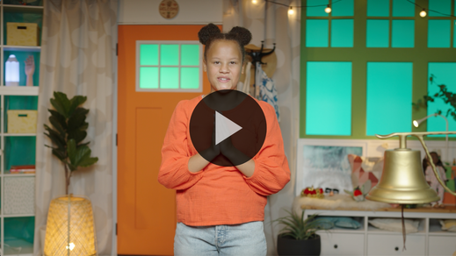

**Ephesians** *(hands at waist, spread apart, palms up and out)*

**4:** *(hands together like a clap)*

**3** *(hands opened to “book”)*

**Make every effort** *(sweep hands out and to the sides)*

**to keep yourselves united** *(bring hands together in a clap)*

**in the Spirit,** *(clap twice with the syllables of “Spirit”)*

**binding yourselves together** *(wrap arms around like a hug)*

**with peace.** *(bow head and whisper)*

Great job, friends! We’ll continue learning our Faith Verse and saying it together.

**Closing**

Did you learn more about how powerful God is today? *(Group response)* I loved worshipping God with you by singing. It’s so good to pray with you and believe God can do miracles just like He did for Peter. Our God is so powerful, isn’t He? *(Group response)*

• *Play the* ***Faith Fact Sound*** *video (bell ringing).*

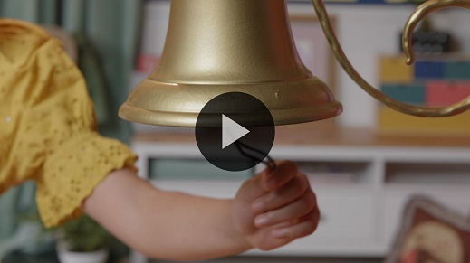

That sound means it’s time to say our Faith Fact one more time. **Our prayers are powerful**.

• *Show the* ***Faith Fact Slide.***



Let’s use our most powerful voices to say it. **Our prayers are powerful**. Let’s point up to our powerful God when we say it *(demonstrate)*. **Our prayers are powerful**.

**Dismissal to Small Groups**

Great job! It’s time to go to our small groups where you’ll have lots of fun with your friends.

• *Dismiss the kids by groups.*

|  |
| --- |
| ***Leader Tip:*** *This can be done by assigning color teams or by age groups. Note that some young preschoolers may not know their age. Using a colored sticker, jersey, or wristband will help separate the kids and help identify their small groups.* |

**Small Group**

**25 Minutes**

*See supplies and prep instructions at beginning of session or in each activity below.*

|  |
| --- |
| ***Leader Tip:*** *Small groups can alternate to each circle, or all groups can do each activity at the same time. If you choose to alternate, you will need at least one leader per circle.* |

**Circle 1**

**Group Connection**

**Bound Together**

|  |
| --- |
| ***You Will Need***  *• Rope or jump rope long enough for each kid to place one hand on it while sitting in a circle.*  *No prep needed for this activity.* |

In our Bible story, we learned that a group of God’s people gathered together to pray for Peter. Why did Peter need prayer? *(Allow responses.)* Peter was in jail because he was living for Jesus. That wasn’t fair at all! Did God answer everyone’s prayers for Peter? *(Group response)* Yes, He did! They were amazed at the miracle God did.

When we spend time praying together, it unites our hearts. That means it helps us have the same goal. That is exactly what our Faith Verse says.

[Ephesians 4:3](https://ref.ly/logosref/Bible.Eph4.3) (NLT)

Make every effort to keep yourselves united in the Spirit, binding yourselves together with peace.

One way we can keep ourselves united is by spending time together. I’ll pass the end of the rope to the person next to me. When I pass it, I’ll tell everyone one thing I like to do with my friends. As the rope gets passed to you, you’ll share what you like to do with your friends. When we’re done, we’ll all be holding onto the rope together.

• *Share and pass the rope.*

Awesome! Now let’s say our Faith Verse! Keep holding onto the rope. I want everyone to repeat after me. Ready?

• *Lead the kids through Faith Verse.*

[Ephesians 4:3](https://ref.ly/logosref/Bible.Eph4.3) (NLT)

Make every effort to keep yourselves united in the Spirit, binding yourselves together with peace.

Great job! We’re learning God’s Word together. Let’s pray together like Peter’s friends did. Let’s take turns sharing one thing you want to pray for. Then, I’ll pray at the end. Keep holding onto the rope.

• *Give each kid an opportunity to share a prayer request.*

• *Pray together for the needs they shared.*

That was amazing! I loved learning more about each of you. I really liked praying with you.

**Circle 2**

**Activity Page Time**

**Power of Prayer**

|  |
| --- |
| ***You Will Need***  *•* ***Small Group Activity Page 1****, one per kid*  *•* ***Small Group Activity Page 2****, one per five kids*  *• Tape*  *• Scissors, one per kid*  *• Glue sticks, one per kid*  ***Getting Ready***  *• Print copies of the* ***Small Group Activity Page 1****, one per kid.*  *• Print copies of the* ***Small Group Activity Page 2****, one per five kids.*  *• Optional: Cut apart the four strips so each kid can have a set.*  *• Optional: Glue the four strips into a chain for each kid.* |

We learned that **Our prayers are powerful**. Like Peter’s friends in our Bible story, when we pray together, God listens. When Peter was thrown in jail, he didn’t know when or if he could get out.

• *Give each kid a copy of the* ***Small Group Activity Page****, scissors, and a glue stick.*

I’m going to give you four strips with our Faith Fact words on them. Carefully cut them apart and glue them together to make a paper chain. Then, lay the chain over Peter’s hands.

• *Assist kids as needed while they make a paper chain.*

This is the great part! Peter’s friends didn’t know if Peter would get out of jail either, but they knew God could help Peter. They got together and prayed. Then, they prayed some more. What happened? *(Allow responses.)* God set Peter free! Now, take away those chains and tape them at Peter’s feet. Because of God, **Our prayers are powerful.**

• *Allow time for the kids to tape the paper chain on their page.*

• *During the activity, interrupt and practice the Faith Fact:* **Our prayers are powerful.**

• *Play the* ***Faith Fact Sound*** *video. Review the Faith Fact even if you can’t play the sound.*



**Circle 3**

**Feet-to-Floor Game Time**

**A-Mazing Race**

|  |
| --- |
| ***You Will Need***  *• Floor-safe tape*  *• Rectangular metal cake pans, one per group*  *• Marbles or table tennis balls*  ***Getting Ready***  *• Tape a maze path on the floor for kids to follow.* |

Who is ready to play a fun game? *(Group response)* Awesome, I was hoping you would want to play a game. For today’s game, you get to choose to play on your own or with a partner.

• *Hold up the cake pan and the marble and demonstrate what the kids will do.*

If you choose to play the game by yourself, you will need to balance the marble on the cake pan. Here’s the challenge. You need to hold the pan upside down so that you won’t have the edges to help you. If you choose a partner to play with, it will be a lot easier. You’ll each hold an edge of the pan, but the pan will be right side up with the marble inside. The edges will help you.

The goal is to make it to the end of the path without dropping the marble. If you’re ready to play, let me hear you say, “Oh, yeah!” *(Group response)*

• *Help kids line up and select partners.*

• *If a kid chooses to do the activity on their own, allow them to try. When the marble falls, let them try again with a partner.*

• *Play again as time permits.*

You did great! Which was harder, doing it by yourself or with a friend? *(Group response)* It was way harder to do it by yourself. As soon as you had someone helping you carry the pan, it got so much easier. In our story, we learned the same is true when we choose to partner in prayer with other people. In fact, that’s what our Faith Fact means when it says **Our prayers are powerful**.

The word *our* means there’s more than one person. Let’s always remember to pray together. Why don’t we show our strong muscles and say our Faith Fact as loud as we can together? Ready? **Our prayers are powerful.**

**Circle 4**

**Hands-On Learning**

**Powerful Prayer Object Lesson**

|  |
| --- |
| ***You Will Need***  *• Large foam plates, one per kid and leader*  *• Water*  *• Disposable tablecloth*  *• Black pepper in shaker*  *• Liquid dish soap in a bowl*  ***Getting Ready***  *• Arrange plates in the center of the disposable tablecloth on a table or the floor.*  *• Add enough water to cover the bottom of each plate.* |

Sometimes we face big problems in life like Peter did when he was in jail. I’ve got an object lesson to share with you about that. We’ll let the pepper represent our problems.

• *Shake the pepper to cover the water on the plates.*

It might feel like when you have problems that you don’t know what to do. There is one thing we can always do. We can always pray for God to help us.

• *Use your finger to stir the water and move the pepper around.*

• *Allow the kids to stir the water on their plates.*

In our Bible story, we learned that we can also pray together and that **Our prayers are powerful**. When we pray together, amazing things can happen. We’ll use some soap to represent our prayers. After you dip your finger in the soap, hold it up like you’re pointing to God.

• *Have each kid dip the tip of one finger into the soap.*

Big things can happen when we pray together for each other’s problems. To show you what that’s like, when I count to three, we’ll all touch the water with our fingers at the same time right in the center of our plate. Ready? 1, 2, 3. Touch the water.

• *Have the kids touch their plates at the same time. The pepper will scatter to the edge.*

What happened to our problems? *(Allow responses.)* They got out of the way. The amazing thing to remember is whether you pray by yourself or with someone else, God is always listening. When we pray together, we know that **Our prayers are powerful.**

**Dismissal**

• *Play the* ***Faith Fact Sound*** *video (bell ringing).*



• *Show the* ***Faith Fact Slide.***



Before we go, let’s say the Faith Fact together one last time. **Our prayers are powerful.** Great job! I had a great time learning more about God’s Word with you. See you next time!

• *Send home the* ***Small Group******Activity Page*** *with each kid.*

• *Remind parents that there are* ***Family Devotions*** *available on the app to do with their kid.*

• *Tell everyone the date and time for the next session.*